Application and Hiring Timeline

Position Opening
April 10, 2017

Application Deadline
April 23, 2017

Terms of Employment

Contract Length
257 days

Current Salary Range
$96,984-$116,388

Benefits
Health benefits and PERS pick-up

Start Date
July 1, 2017

Address all inquiries and application materials to:

Dandy Stevens—Assistant Superintendent
Silver Falls School District
612 Schlador Street
Silverton, Oregon 97381
Phone: 503-873-5303
Fax: 503 873-2936

E-Mail: stevens_dandy@silverfalls.k12.or.us

Job description can be found on the district Web Site
www.silverfalls.k12.or.us

Applications can be found via the district website listed above, Employment link to Talent Ed. For questions, contact Sandy Sprauer, Human Resources secretary at sprauer_sandra@silverfalls.k12.or.us

Silver Falls School District provides equal employment opportunities (EEO) to all employees and applicants for employment without regard to race, color, religion, sex, national origin, age, disability, or genetics. For more information see District Policy GBA – Equal Employment Opportunity.

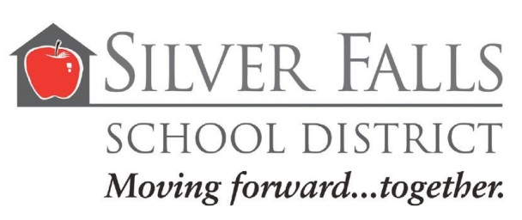
Experienced Principal sought for the position of:

Principal
Silverton High School

MISSION STATEMENT:

Together…cultivating character and academic growth in each student. Every day.

CORE VALUES:

*Student engagement resulting in
maximum individual growth
*Professional excellence
*A culture of integrity, respect and
service
*Unique schools within our
communities.

Welcome

Thank you for your interest in the Silver Falls School District and the position of Principal at Silverton High School. The district is seeking a dynamic individual with principal experience who has a strong background in teaching and learning and experience at the high school level.

Silverton High school encompasses grades 9-12 with approximately 1,300 students and 80 staff members. Silverton High School is part of the Silver Falls School District, a public K-12 school system with a population of approximately 3,900 students. The District has three in-town schools that have grade configurations of K-2, 3-5, and 6-8. Additionally, the District has seven K-8 elementary schools and two elementary Charter schools. Silver Falls is in year three of a five year strategic visioning plan which has served to focus efforts in improving instruction and services in all areas.

The teaching staff at Silverton High is a wonderful mix of seasoned veteran teachers, those relatively new to the profession and many in the middle of their careers. This district prides itself on a high teacher retention rate. Many teachers have spent their entire career in Silver Falls School District. The district maintains a supportive environment for new teachers. The use of Professional Learning Communities is embraced by the district and is a major component of curricular, instructional and staff development.

Silver Falls School district is 240 square miles and is located in Marion and Clackamas Counties at the east edge of the Willamette Valley. In the center of the district is the community of Silverton, 14 miles northeast of Salem. The district is also composed of the communities of Monitor, Marquam and Scotts Mills. The district encompasses the beautifully scenic Silver Falls State Park and the Oregon Garden. It is less than two hours from both the Oregon Coast and the Cascade Mountains.

The successful candidate will…
- Demonstrate successful leadership in a comprehensive high school setting
- Recognize the importance and value of academics within a thriving co-curricular learning environment
- Nurture and sustain a culture of trust, collaboration, learning and high expectations
- Develop operational plans for reaching student achievement and instructional goals that are aligned with the district’s mission, vision, and goals.
- Work collaboratively as part of a team toward improved academic growth and student/family engagement
- Serve as advocate and spokesperson for the school to all stakeholders.
- Implement professional development for administrators, teachers, and staff that is relevant and meaningful.
- Involve teachers in the design and implementation of important decisions and policies.
- Demonstrate knowledge of, and experience with:
- Standards-based instruction & grading
- Professional Learning Communities
- Data driven decision making
- Oregon Graduation Requirements
Professional Skills
- Collaborative Leadership
- Budgeting
- Priority of Educational Opportunity and Equity for all Students
- Group Facilitation
- Academic Data Analysis
- Facilities Management
- Parent and Community Relations
- Articulation of School Vision
- Promoting District Initiatives

Communication Skills
- Excellent verbal and written communication skills with diverse populations.
- Uses positive communications, good listening skills, and has the ability to function as a facilitator of genuine dialogue
- Adapts his or her leadership behavior to the needs of the current situation and is comfortable with dissent.
- Communicates effectively with all stakeholders.
- Demonstrates ability to maintain respectful “two-way” relationship with licensed and classified associations.
Personal Expectations and Integrity
- Demonstrates a high level of honesty, integrity and fairness. Possesses a good sense of humor and a positive attitude.
- Demonstrates a welcoming leadership style with a visible, collaborative approach when working with others.
- Demonstrated ability and willingness to adapt to the Mission and cultural expectations of Silverton High School and Silver Falls School District.
- Willing to think “outside the box”.
- Possesses high energy and stamina, a bright mind and demonstrated firmness tempered with compassion.

QUALIFICATIONS
Possess or qualify for an Oregon Administrative License.
Training and experience in group processing and collaborative decision making, including active involvement in Professional Learning Communities.

